Day38 - Task19 - AWS SQS, AWS MQ, AWS Secrets Manager

AWS SQS (Simple Queue Service):
Amazon Simple Queue Service (SQS) is a fully managed message queuing service that allows different applications or services to communicate with each other without being directly connected.
Instead of Service A talking directly to Service B, Service A places a message into an SQS queue. Service B reads the message whenever it is ready.

Step 1: Login to AWS Console
- Open AWS Console.
- Search: SQS
- Click: Simple Queue Service
Step 2: Create Queue
- Click Create queue
- Choose Standard
- Queue Name demo-queue
- Leave all settings as default.
- Click
- Create Queue
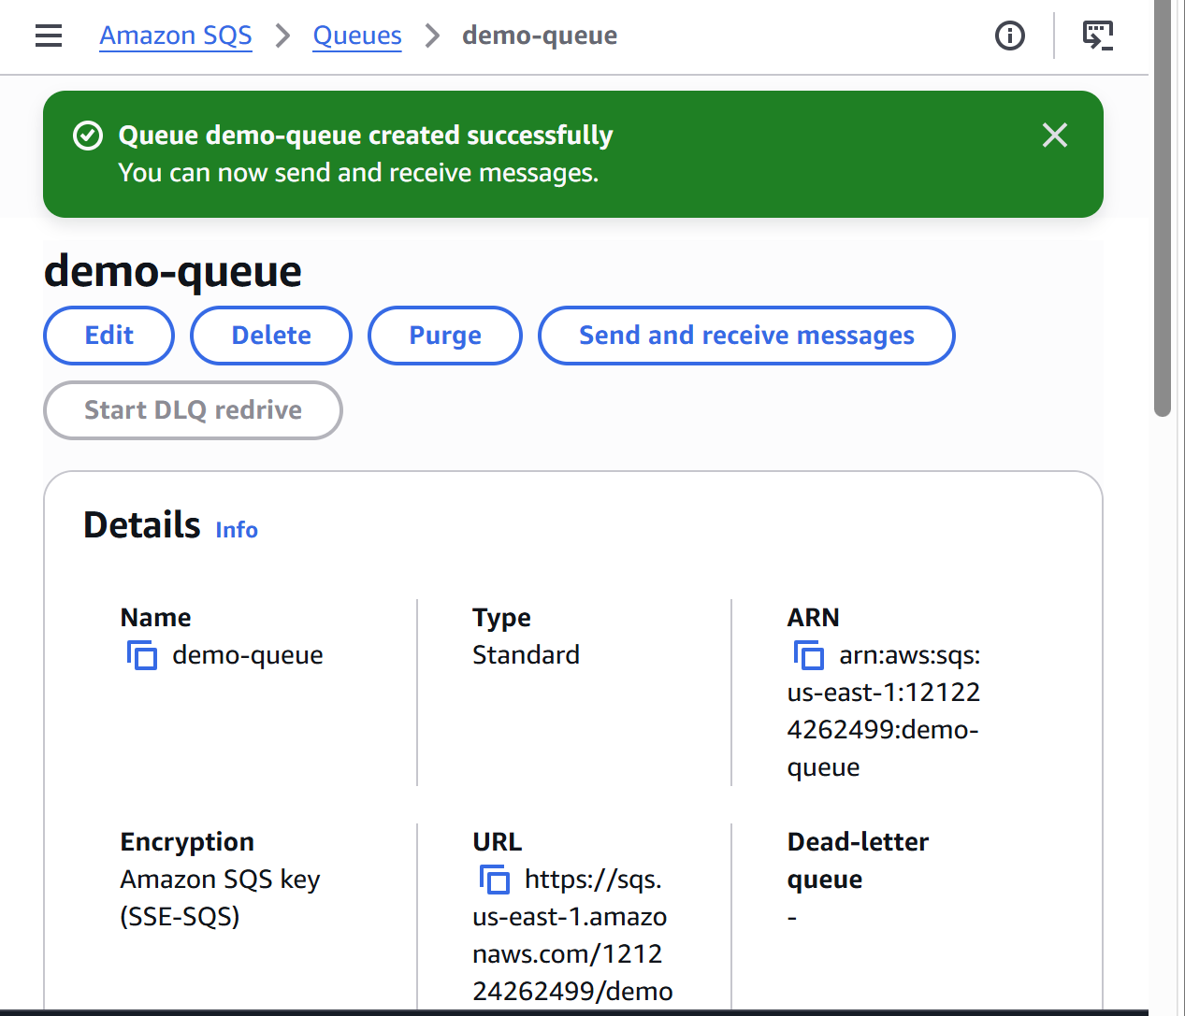
Step 3: Open the Queue
Click demo-queue
Step 4: Send a Message
- Click
- Send and receive messages
- Under Message body, enter:
- Hello AWS SQS
- Click
- Send Message
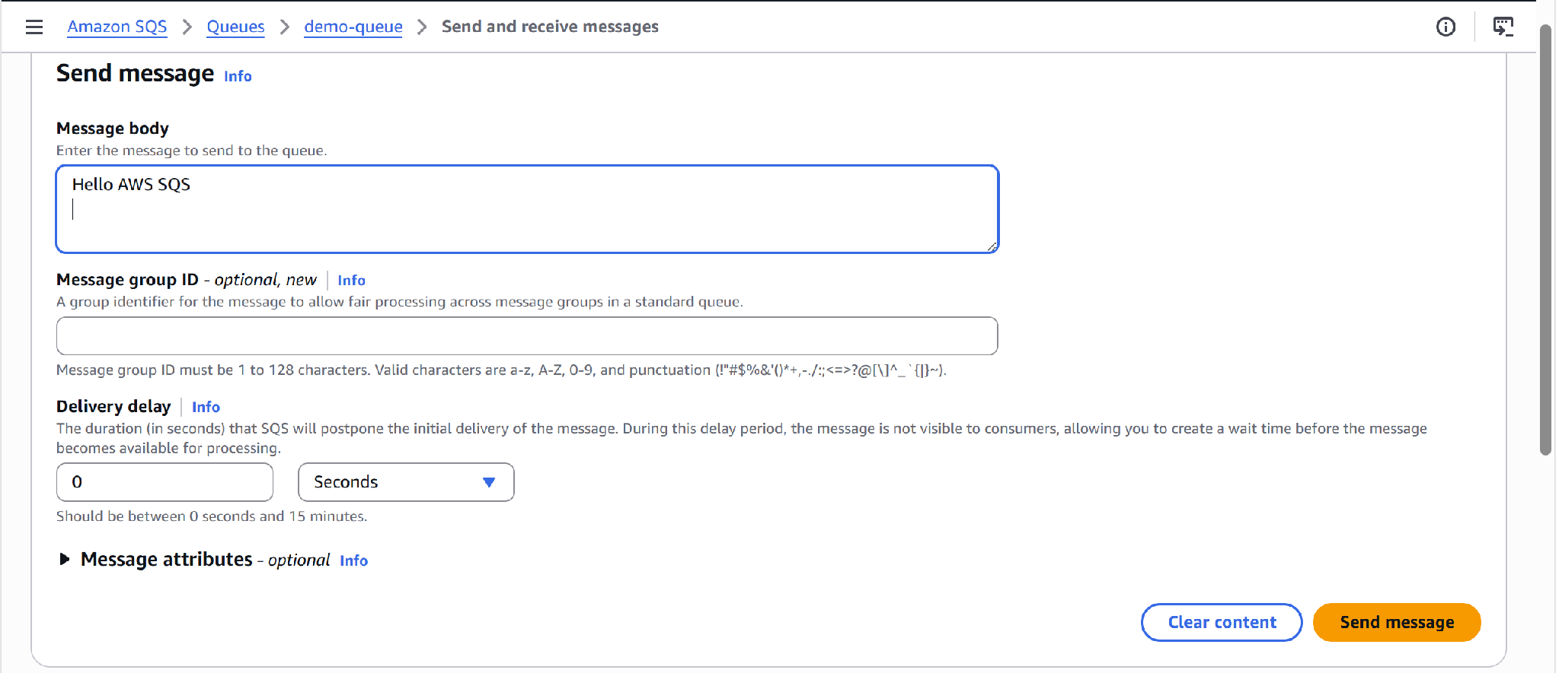
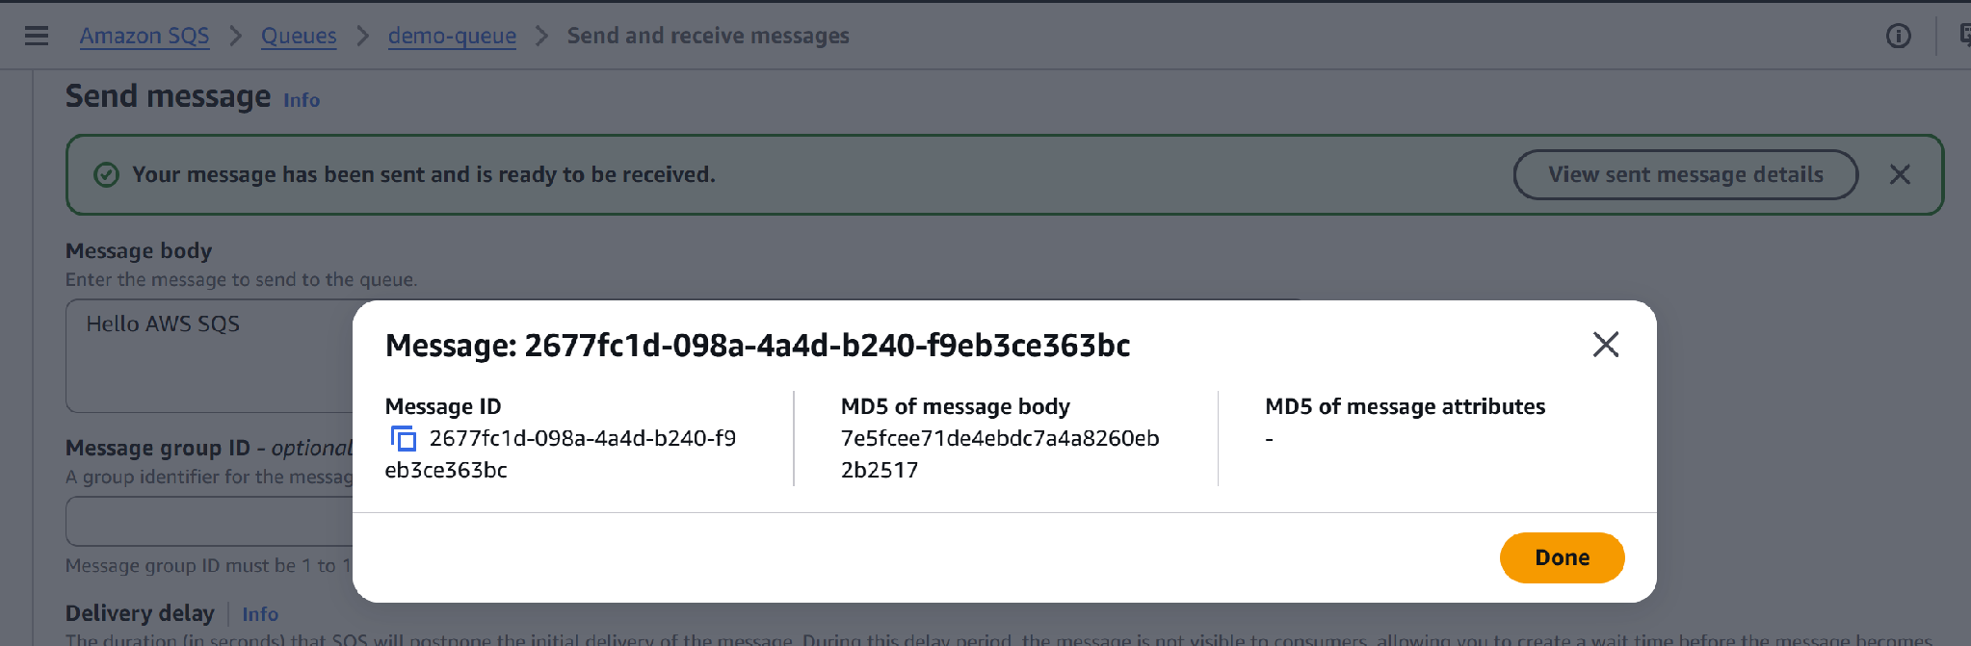

Step 5: Send Multiple Messages
- Send these messages one by one:
- Message One
- Message Two
- Message Three
Step 6: Receive Messages
- Scroll to:
- Receive messages
- Click
- Poll for messages
- You should see:
- Hello AWS SQS
Message One
Message Two
Message Three
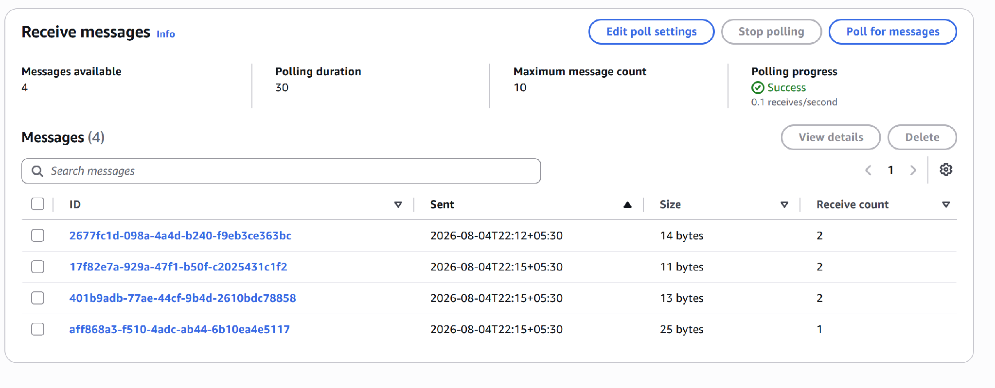
Step 7: Delete Messages
- Select all received messages.
- Click
- Delete
- Messages are permanently removed from the queue.
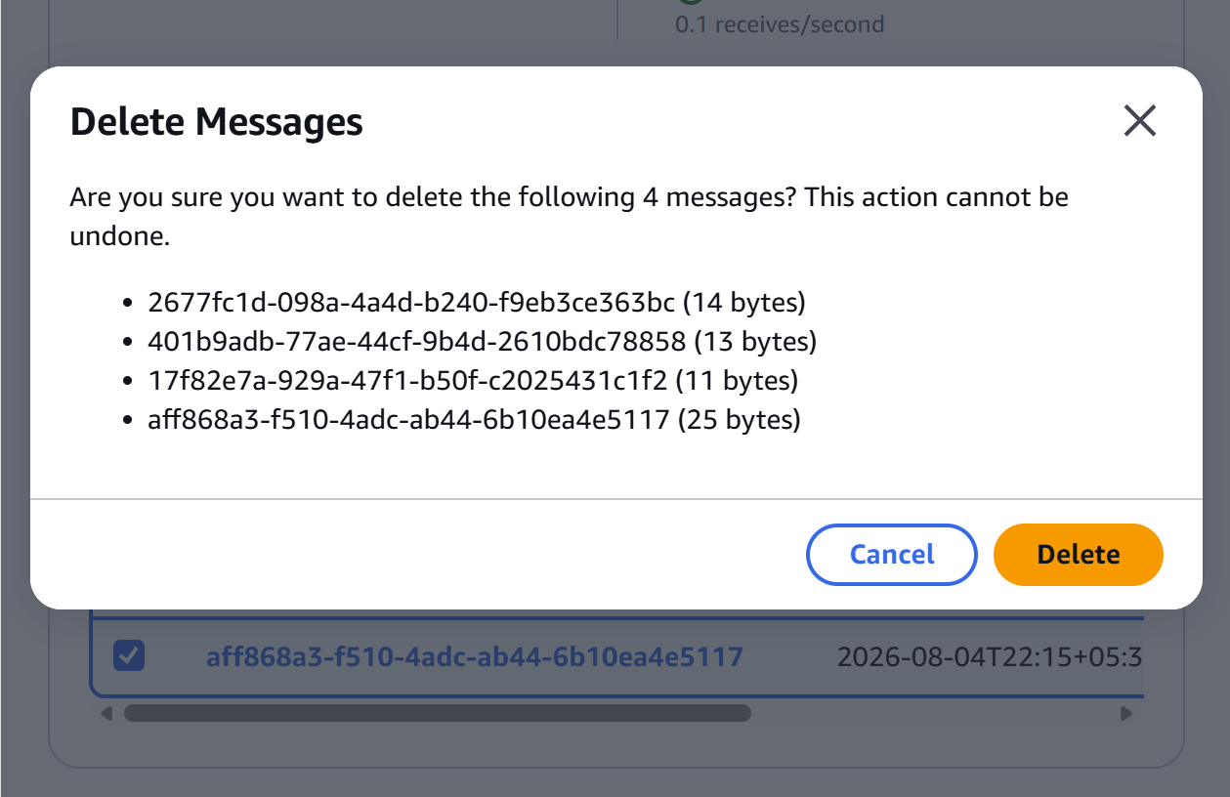
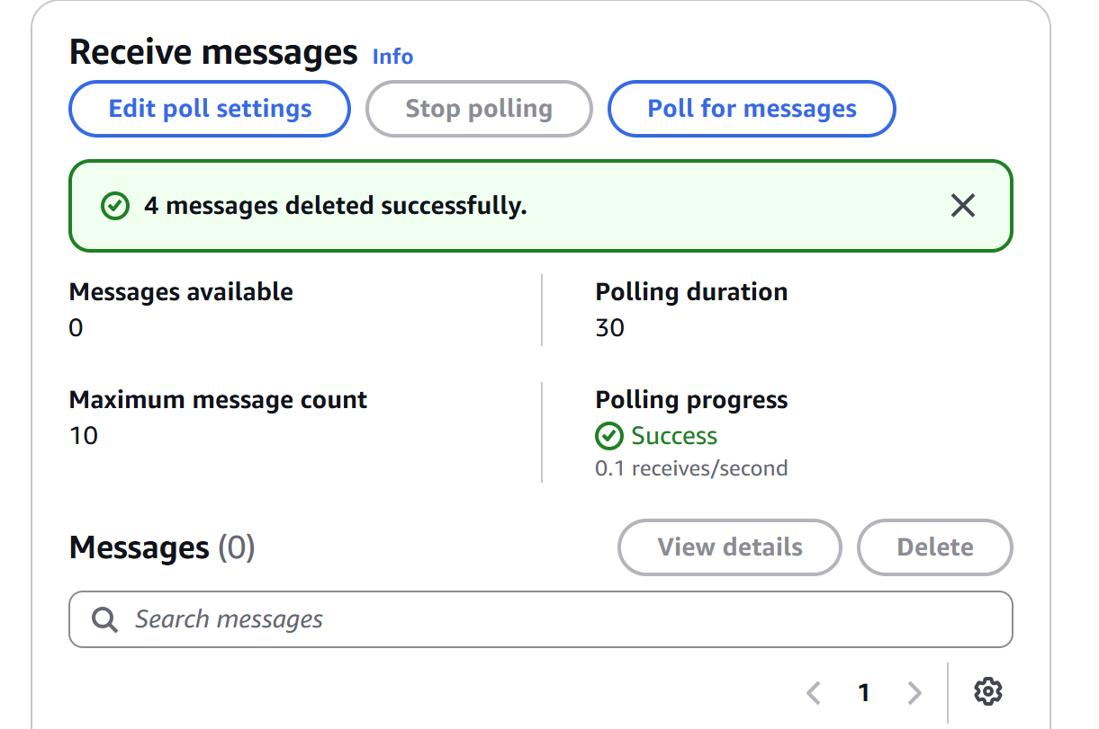

Verify Queue
- Click
- Poll for messages
- Output:
- No messages available
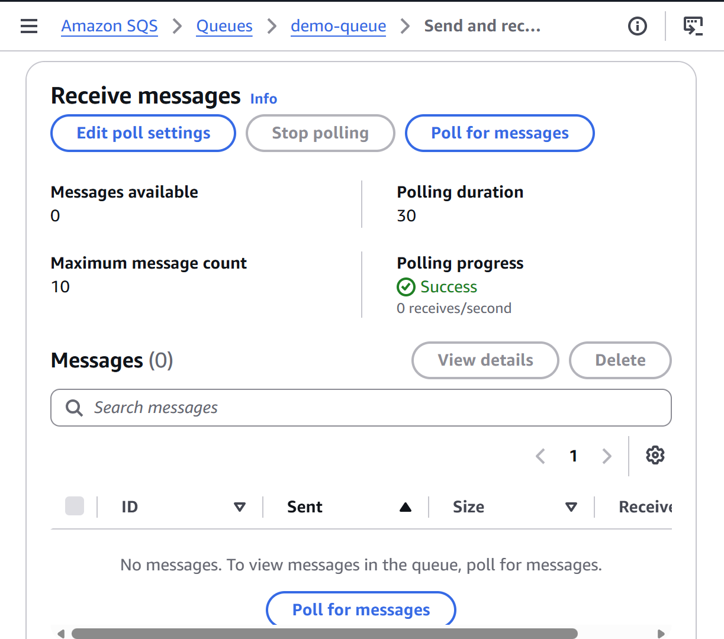
Step 8: View Monitoring
Open your queue, select the Monitoring tab, observe metrics such as:
- NumberOfMessagesSent
- NumberOfMessagesReceived
- NumberOfMessagesDeleted
- ApproximateNumberOfMessagesVisible
- ApproximateNumberOfMessagesNotVisible
These metrics are provided through Amazon CloudWatch.
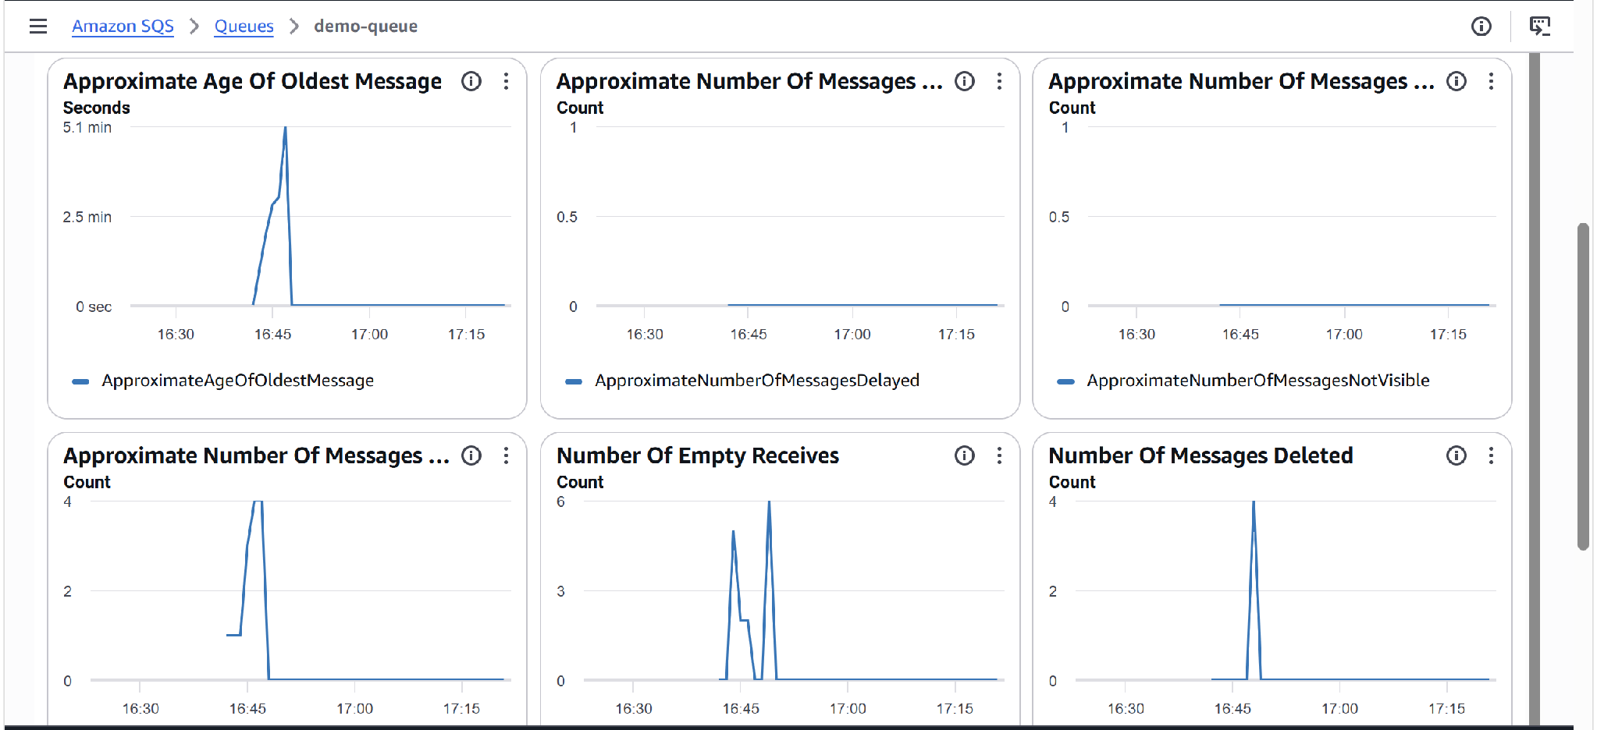

Step 9: Test Visibility Timeout
- Send a new message:
Visibility Test
- Click
Poll for messages
The message appears.
- Do not delete the message.
- Wait about 30 seconds (default visibility timeout).
- Click
Poll for messages
again.
You will see the same message reappear because it was not deleted after being received.
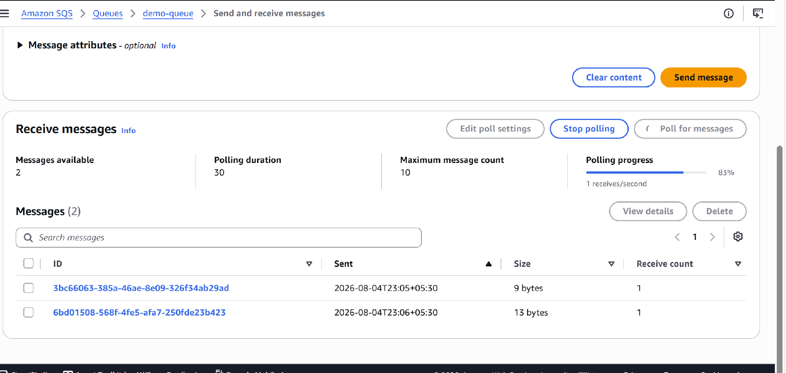

Step 10: Delete the Test Message
Select the message.
Click
Delete
Your queue is now empty.
Step 11: Delete the Queue (Optional Cleanup)
To avoid leaving unused resources:
- Open your queue.
- Click
Delete
- Type the queue name to confirm (if prompted).
- Click
Delete queue
The queue is removed from your AWS account.
What is a Dead Letter Queue (DLQ)?
A Dead Letter Queue (DLQ) is a special SQS queue that stores messages that could not be processed successfully after a specified number of retries.
Instead of failing repeatedly in the main queue, problematic messages are moved to the DLQ so they can be investigated without blocking normal processing.

Amazon MQ:
Amazon MQ is a fully managed message broker service provided by AWS. It supports popular open-source messaging protocols such as:
- ActiveMQ
- RabbitMQ
Amazon MQ makes it easier to migrate existing applications that already use these messaging systems to AWS without changing much of the application code.

Step 1: Login to AWS Console
Open the AWS Console.
Search for:
Amazon MQ
Click:
Amazon MQ
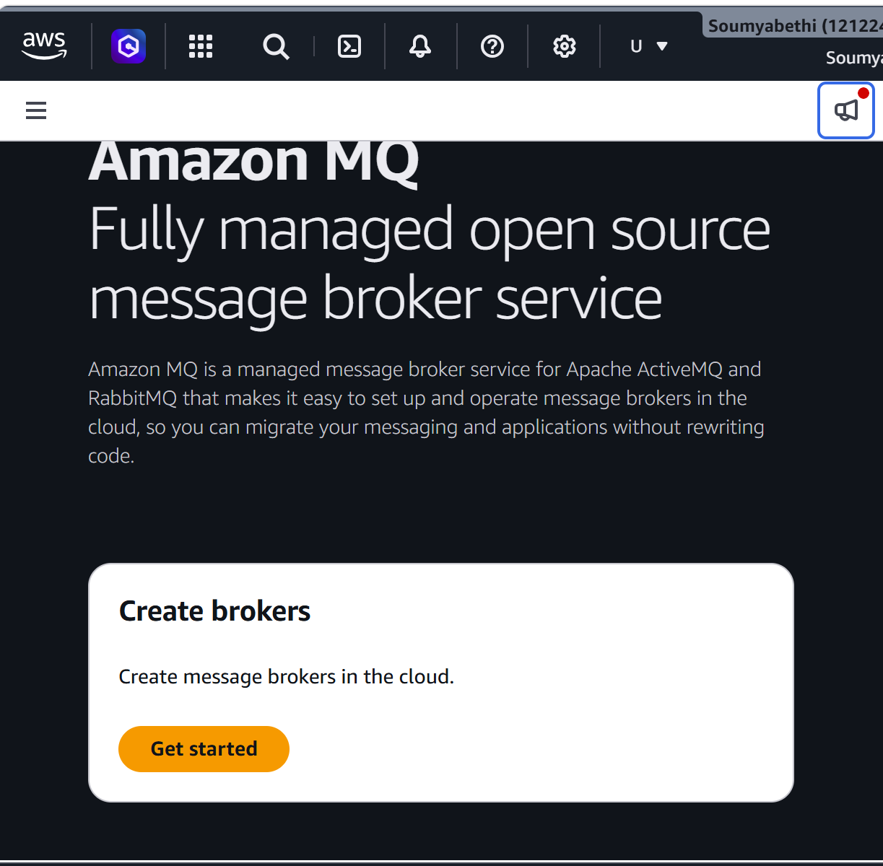
Step 2: Create Broker
Click:
Create broker
Step 3: Select Broker Engine
Choose one:
ActiveMQ
or
RabbitMQ
For beginners, select:
ActiveMQ
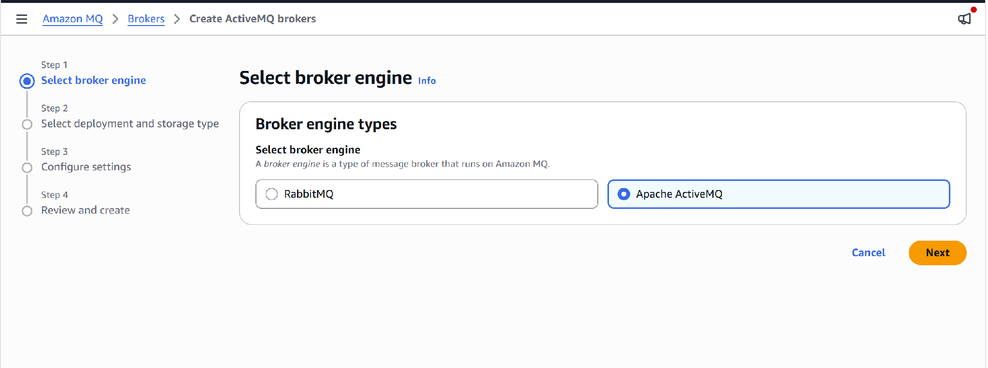
Deployment Mode
For learning purposes choose:
Single-instance broker
This is the lowest-cost option for testing.
Broker Name
Example:
demo-broker
Broker Instance Type
Choose:
mq.t3.micro
(Available in supported regions.)
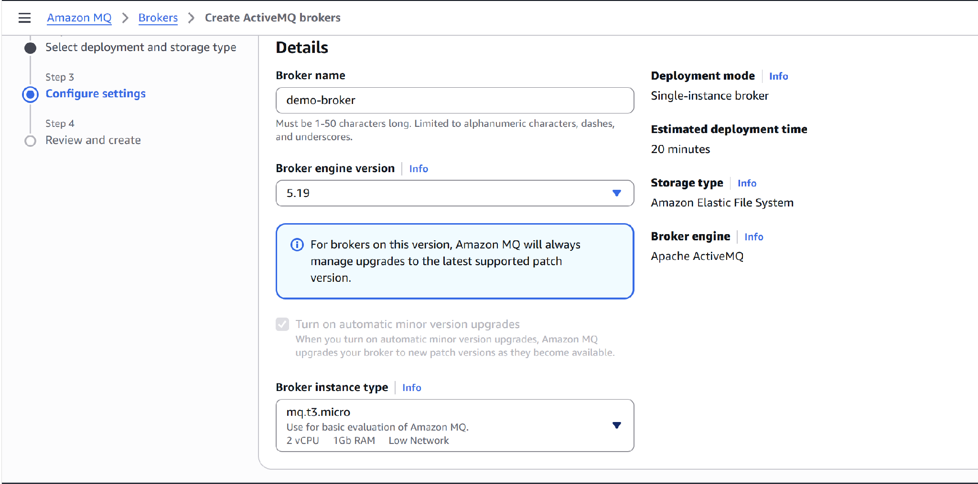

Step 3: Configure Authentication
Enter:
Broker username ---admin
Broker password ---Admin#123456
Store the username and password safely because you will need them to log in to the ActiveMQ web console.
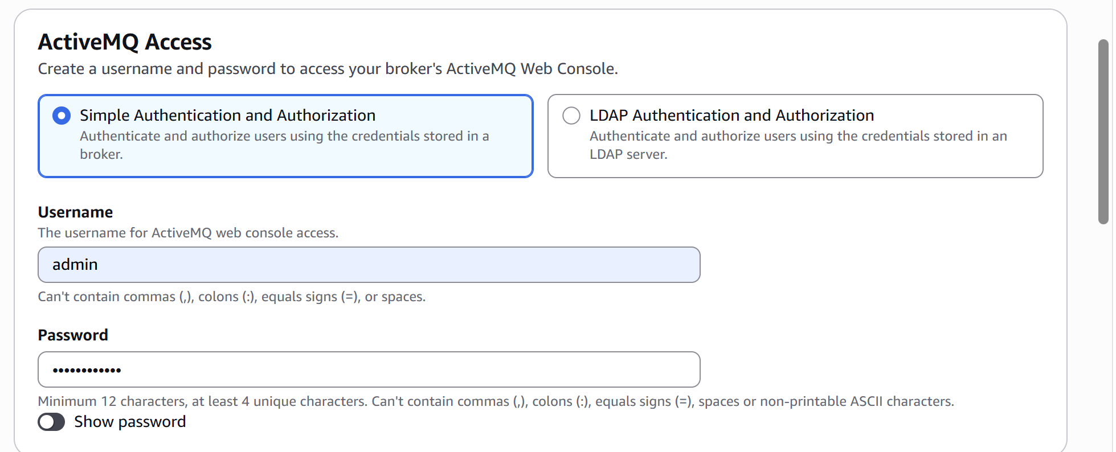
Step 4: Network Settings
Choose:
Default VPC
Select:
Default Subnet
Security Group:
Create new security group
or
Choose existing default security group
For a simple lab, the default VPC and default security group are usually sufficient.
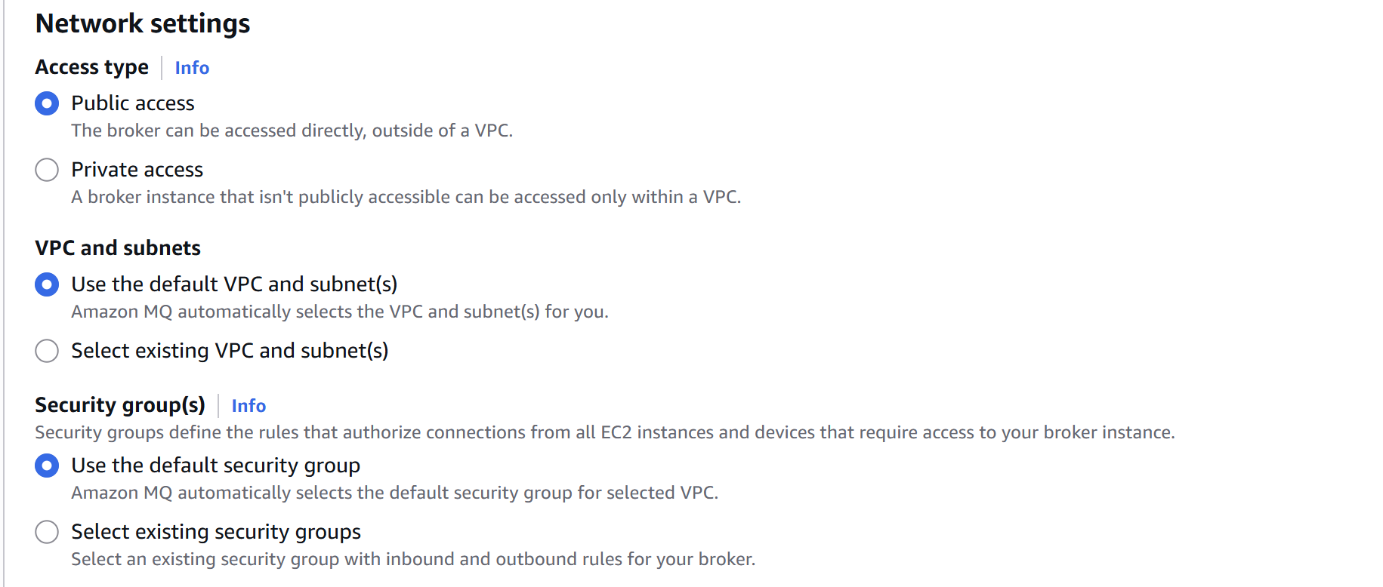
Step 5: Encryption
Keep the default option:
AWS owned CMK
Step 6: Maintenance Window
Leave the default settings.
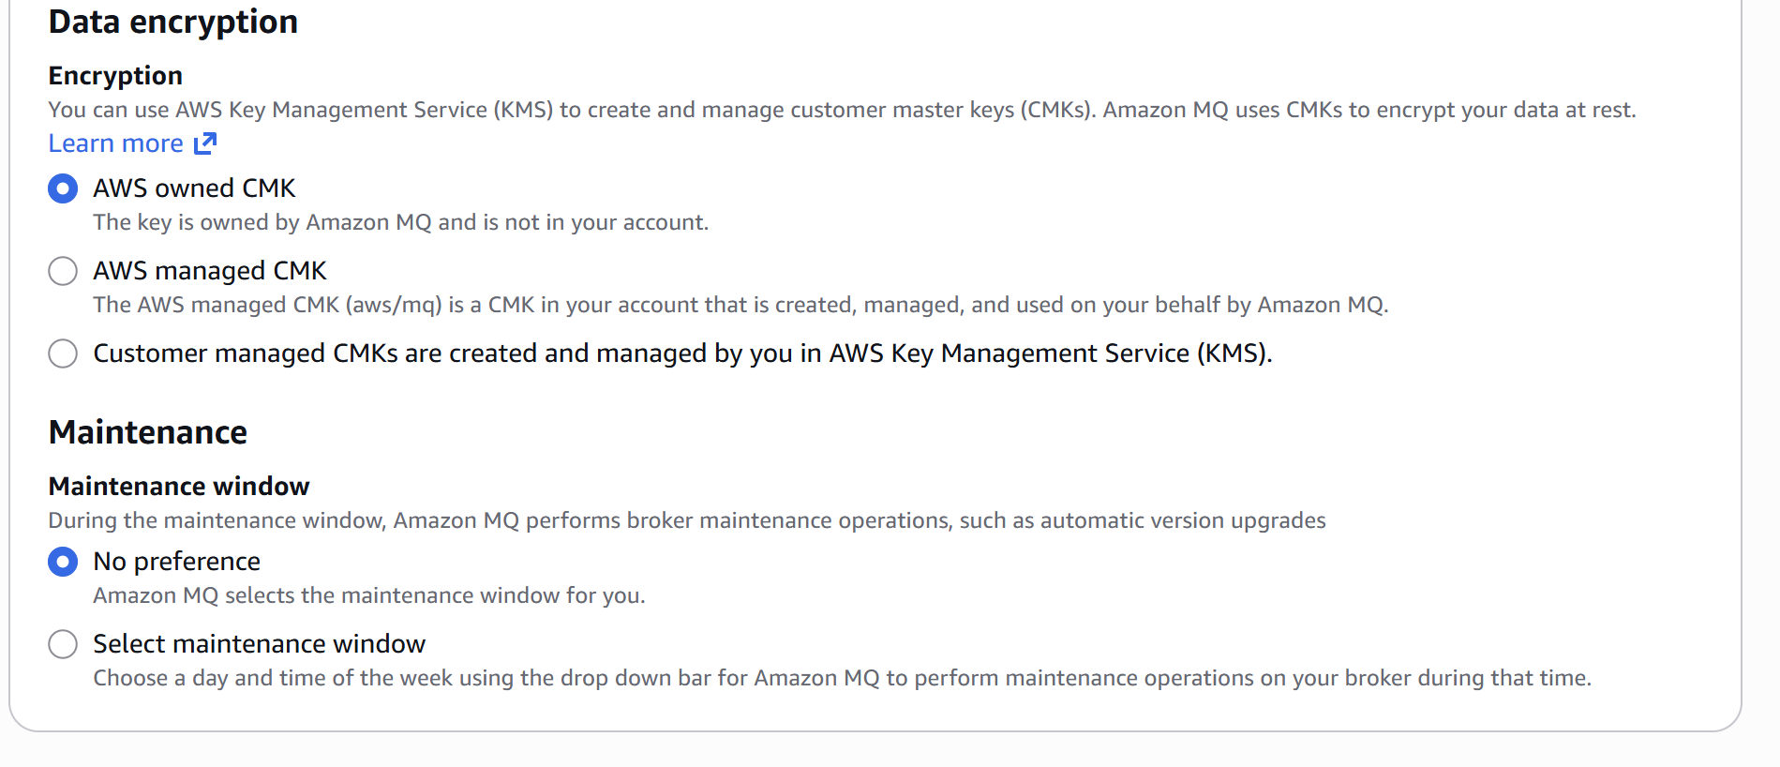
Step 7: Review
Review all settings.
Click:
Create broker
Step 8: Wait for Broker Creation
Broker creation typically takes 15–30 minutes.
Status changes:
CREATION_IN_PROGRESS
↓
RUNNING
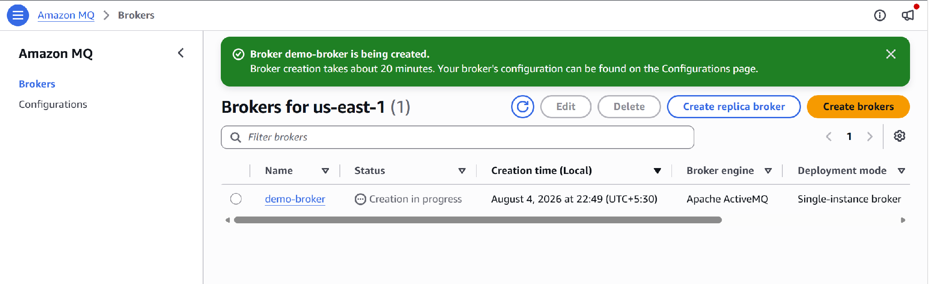

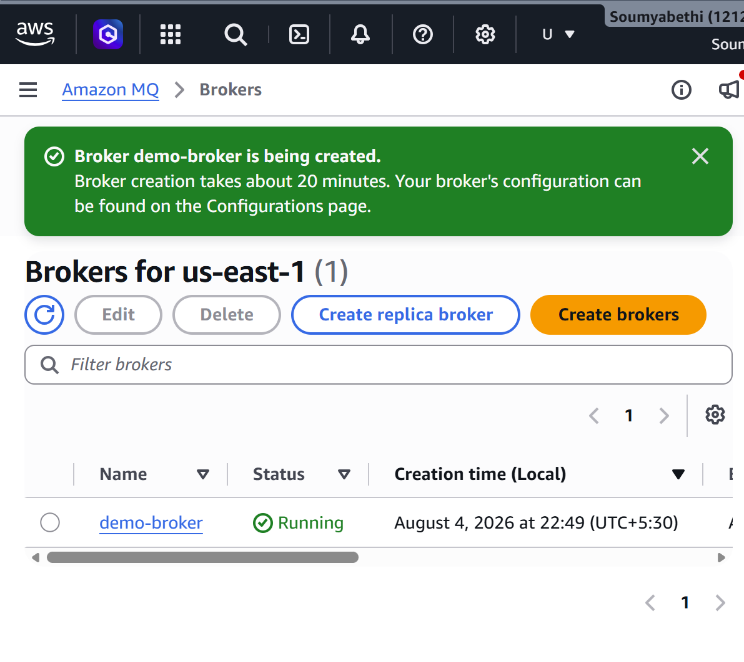

Step 9: Open Broker Details
Click:
demo-broker
You will see information such as:
- Broker ID
- Broker ARN
- ActiveMQ version
- Status
- Endpoints
- Web Console URL
- VPC
- Security Group
- endpoints
Example : ssl://b-e24f4bdd-7406-42da-a258-4825515aae41-1.mq.us-east-1.amazonaws.com:61617
Step 10: Open the ActiveMQ Web Console
In the broker details page:
Click:
ActiveMQ Web Console
Log in using:
Username
admin
Password
Admin#123456
The ActiveMQ administration console opens.
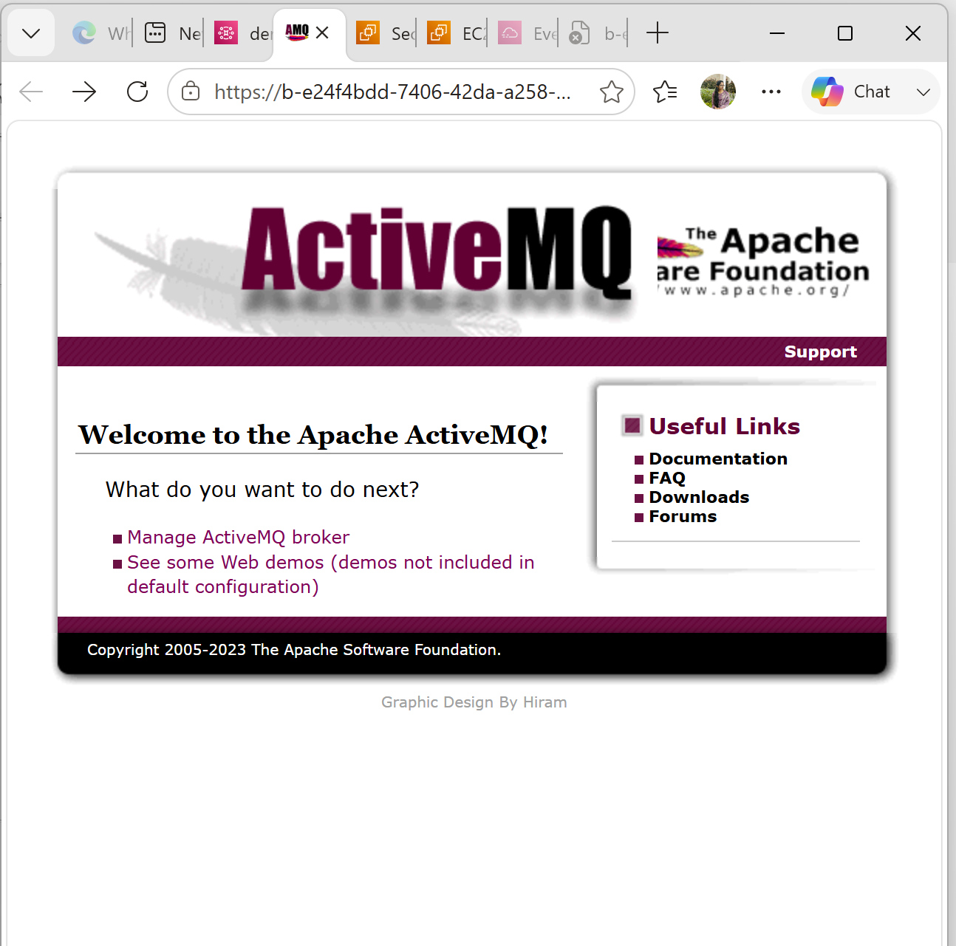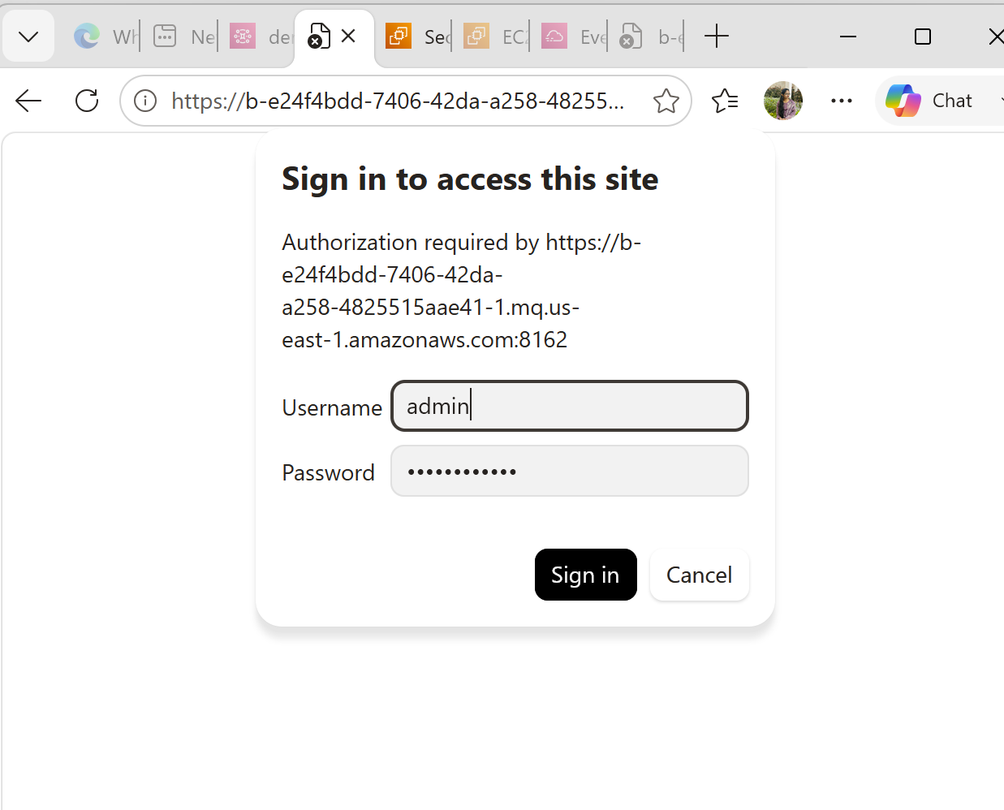
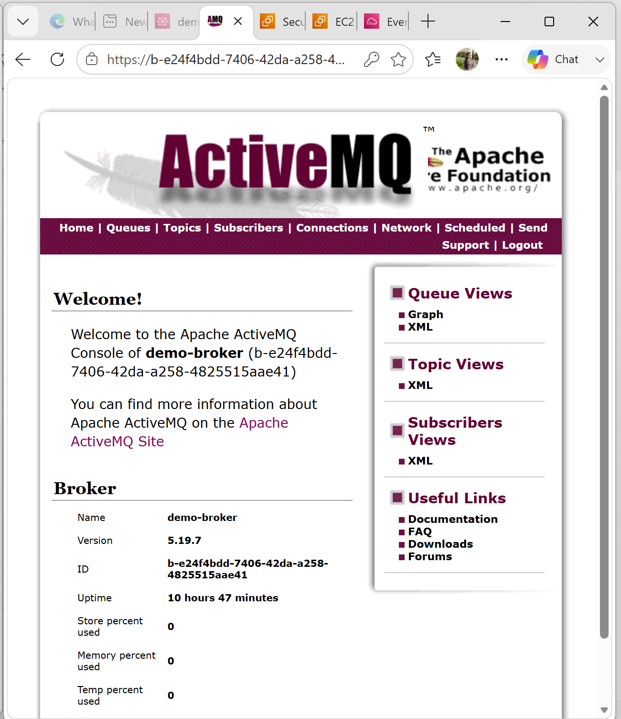
Step 11: Create a Queue
In the ActiveMQ Web Console:
- Click Queues.
- Click Create (or Create Queue, depending on the version).
- Queue name:
orders
Click:
Create
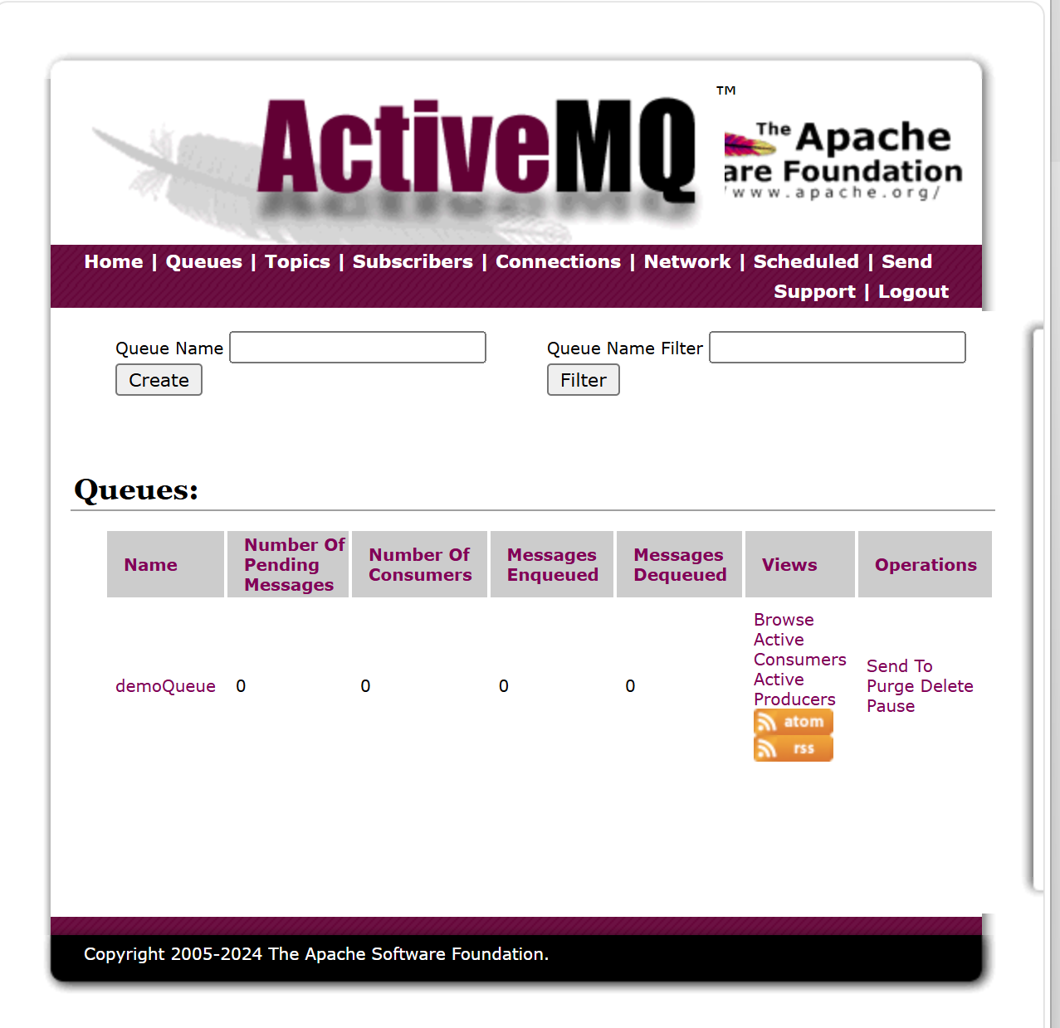
Step 12: Send a Message
Select the queue:
orders
Click:
Send
Message body:
Order ID:1001
Customer:Soumya
Product:Laptop
Click:
Send
The message is stored in the queue.
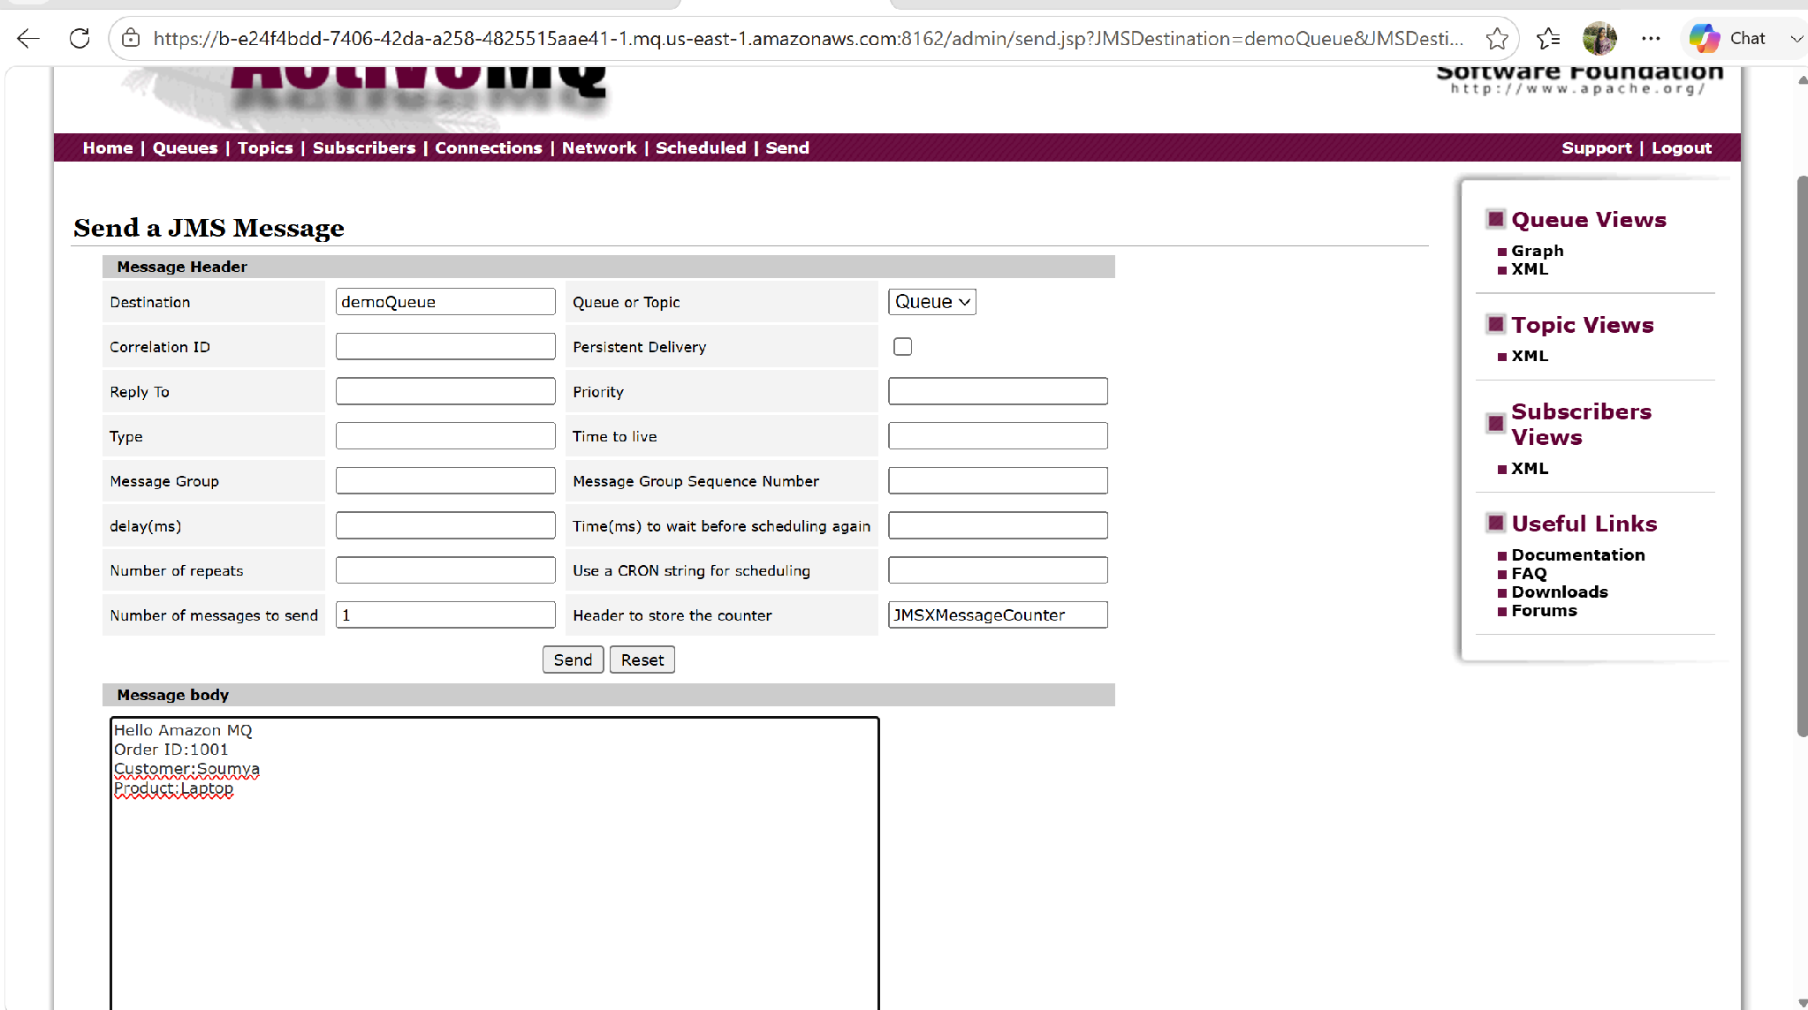
Step 13: Send Multiple Messages
Send these one at a time:
Message 1
Order ID:1002
Message 2
Order ID:1003
Message 3
Order ID:1004
The queue now contains four messages.
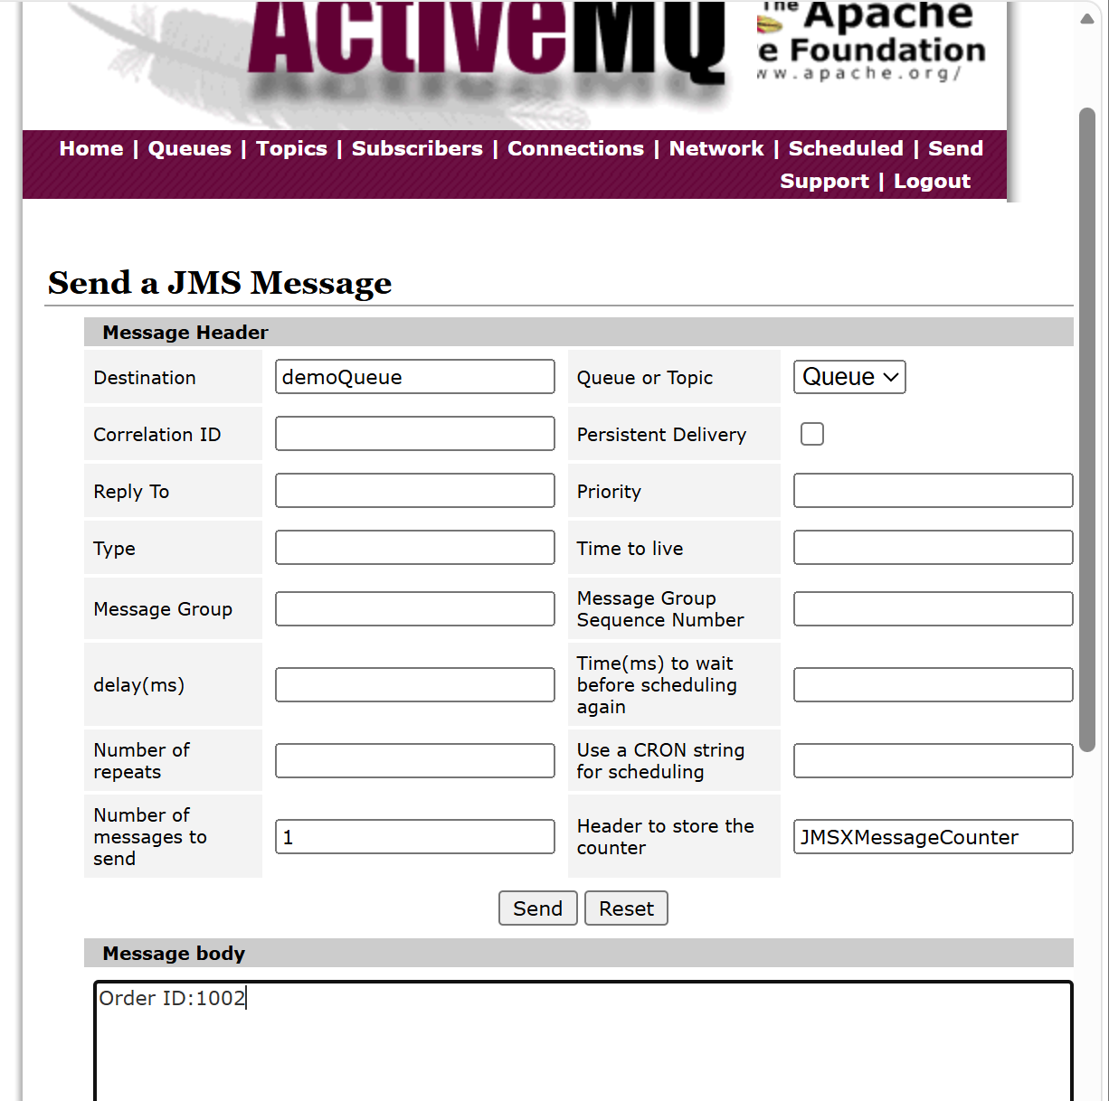
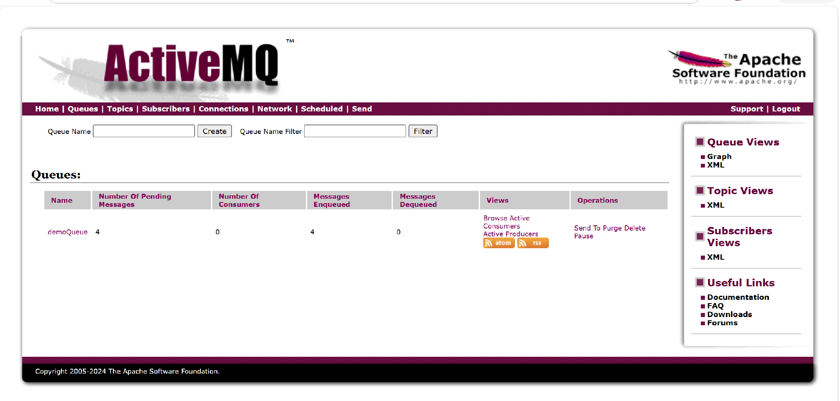
Step 14: Browse Messages
Click:
Browse
You should see:
Order ID:1001

Order ID:1002

Order ID:1003

Order ID:1004
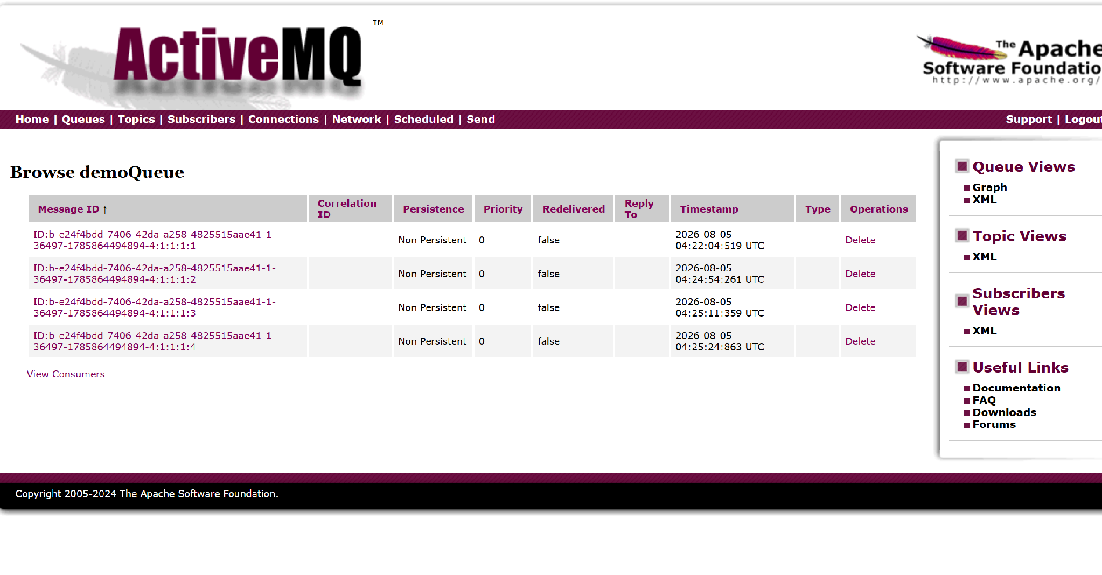

AWS SecretManager
Introduction
AWS Secrets Manager is a service that helps you securely store, manage, and retrieve sensitive information (secrets) such as:
- Database usernames and passwords
- API keys
- Access tokens
- SSH keys
- Third-party application credentials
Instead of storing passwords inside your application code or configuration files, you store them in AWS Secrets Manager. Applications can retrieve the secrets securely whenever they need them.
Step 1: Login
Open AWS Console.
Search Secrets Manager
Click AWS Secrets Manager
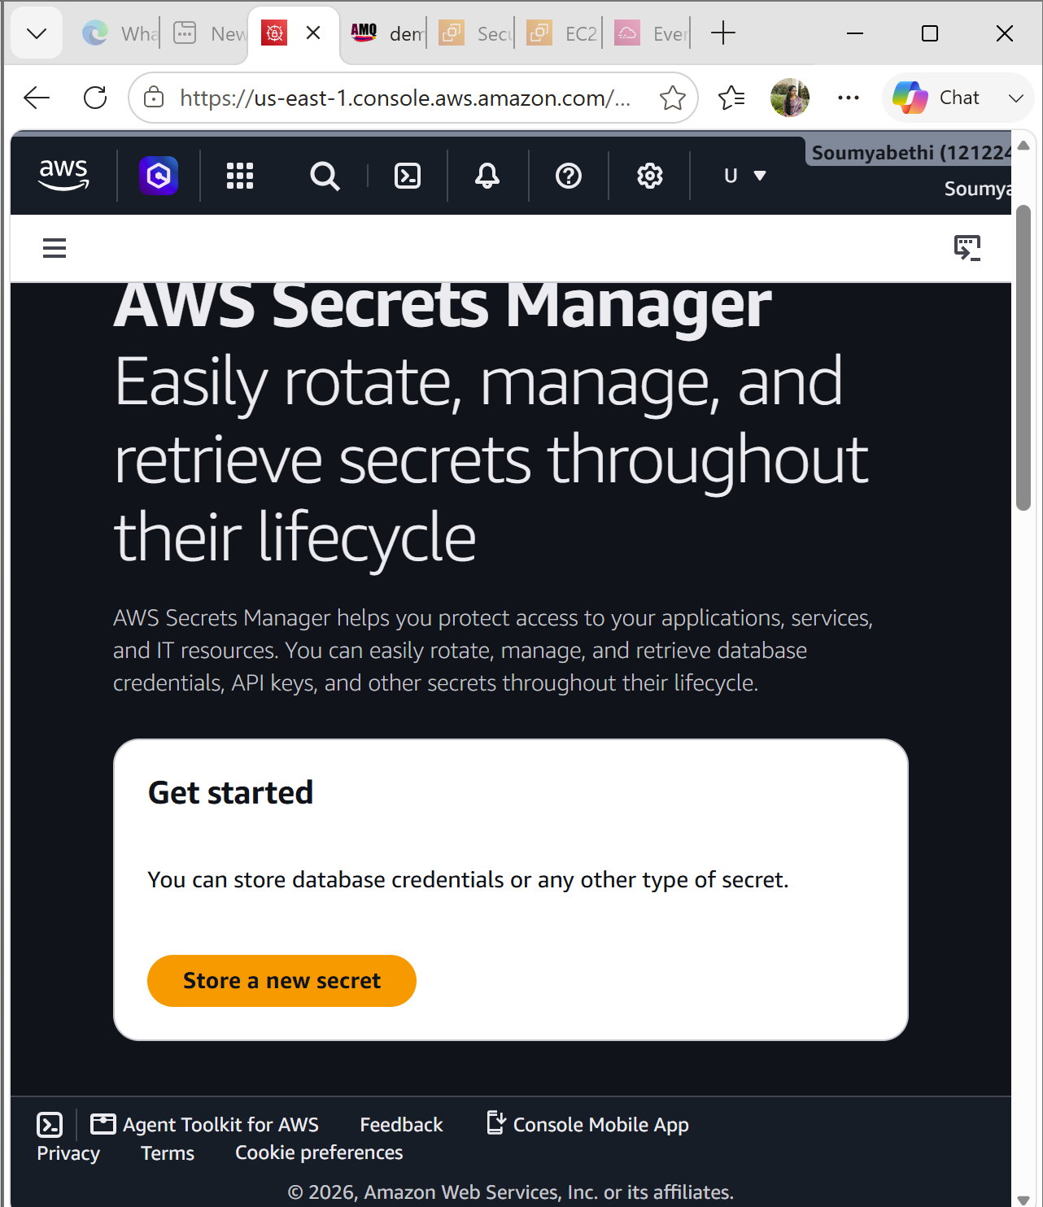

Step 2: Create a Secret
Click Store a new secret
You will see different secret types.
Choose
Credentials for Amazon RDS database
or
Other type of secret
For this lab choose
Other type of secret
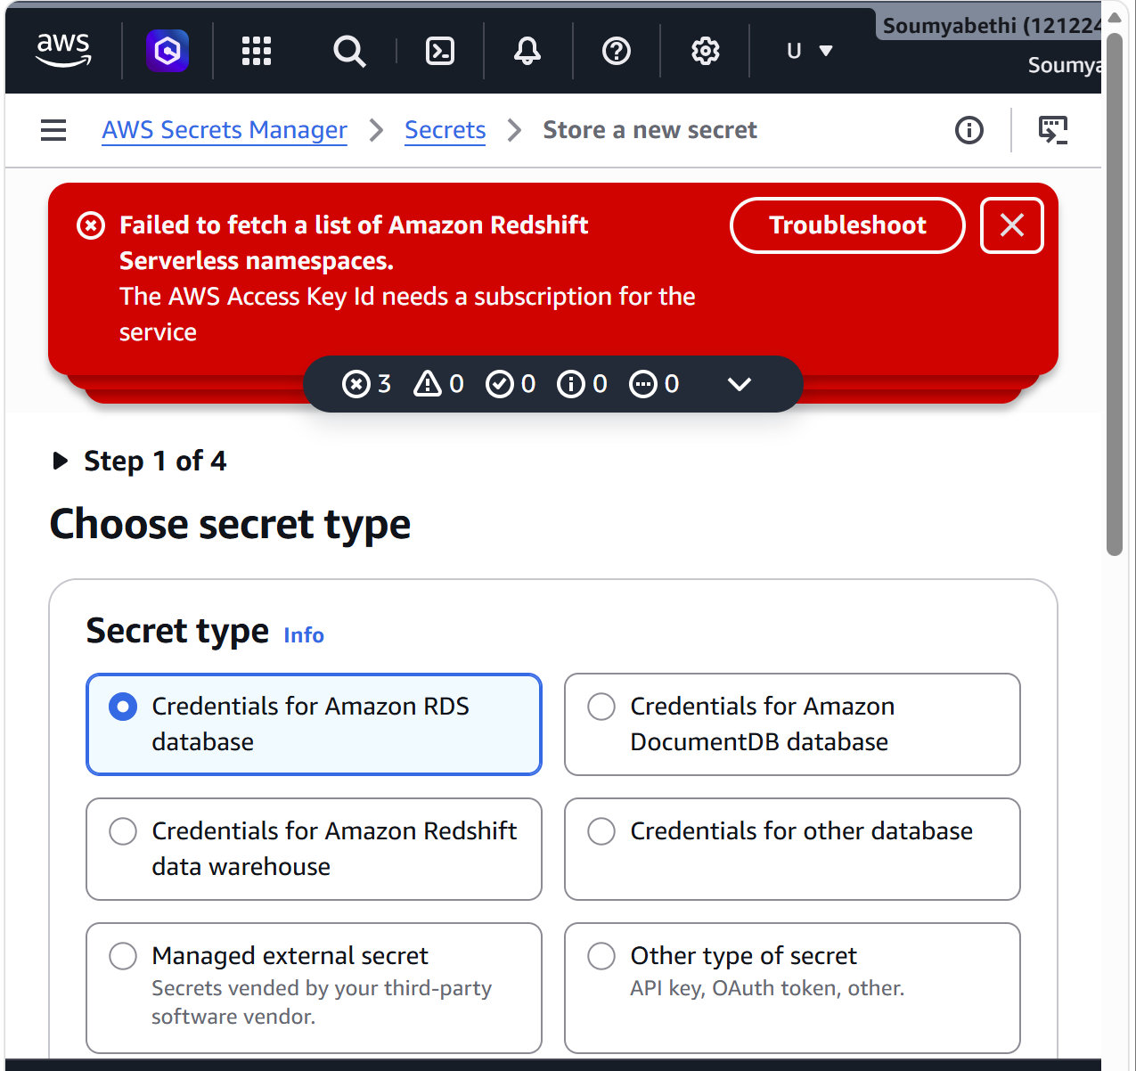

Step 3: Add Secret Values
Enter Key
username
Value
admin
Click
Add row
Enter
Key
password
Value
MyPassword@123
Example
Key | Value
username | admin
password | MyPassword@123
Click
Next
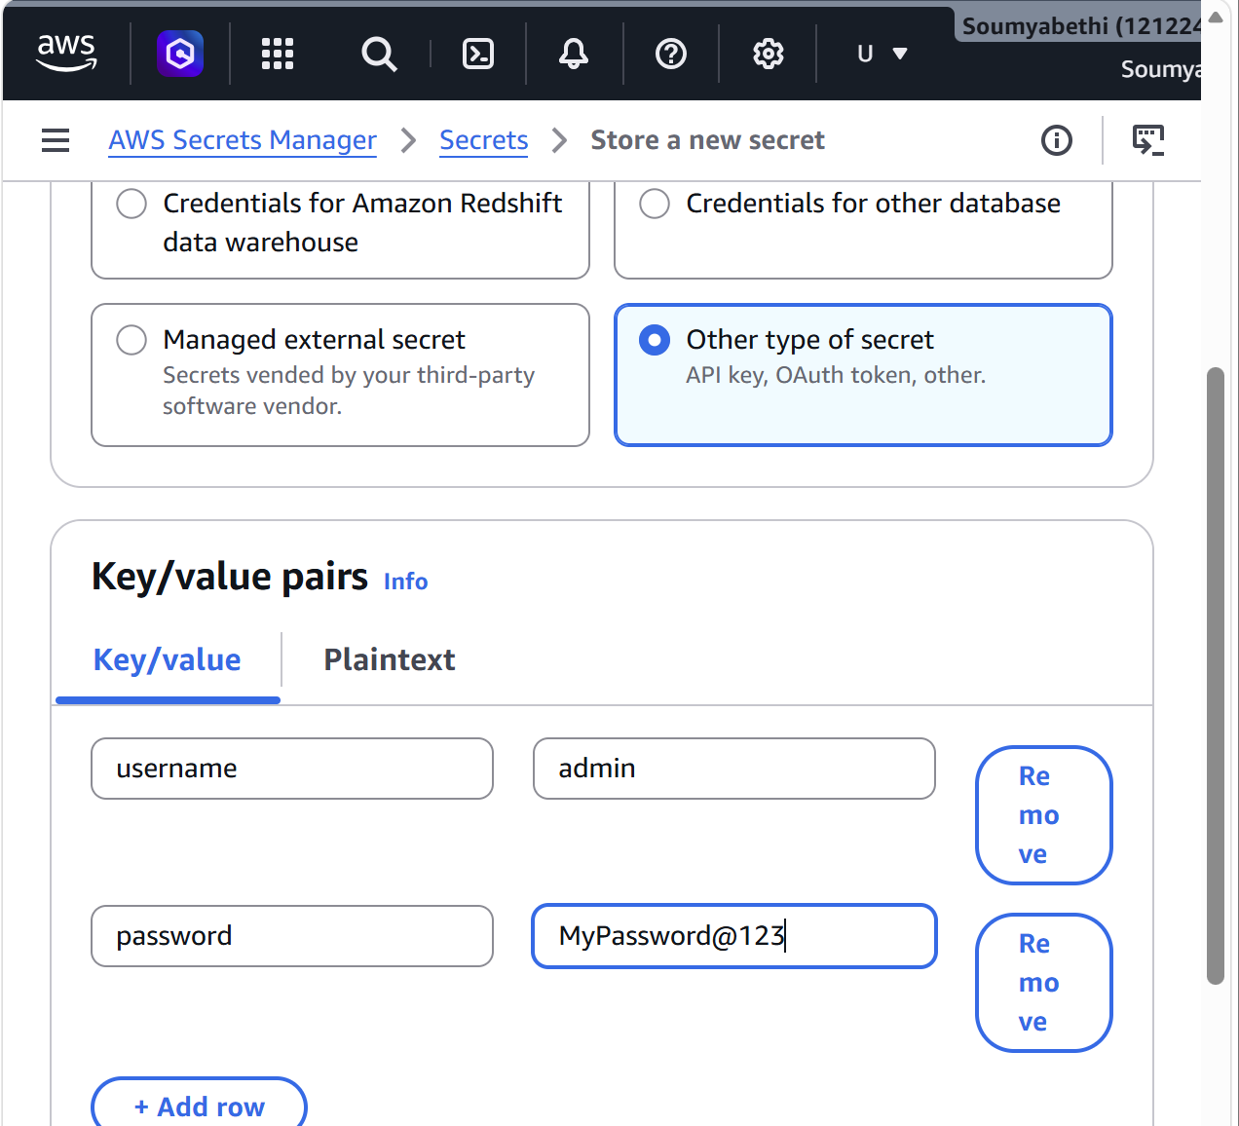

Step 4: Configure Encryption
AWS automatically selects
aws/secretsmanager
This is the default KMS key.
You can also choose your own Customer Managed Key if required.
Click
Next
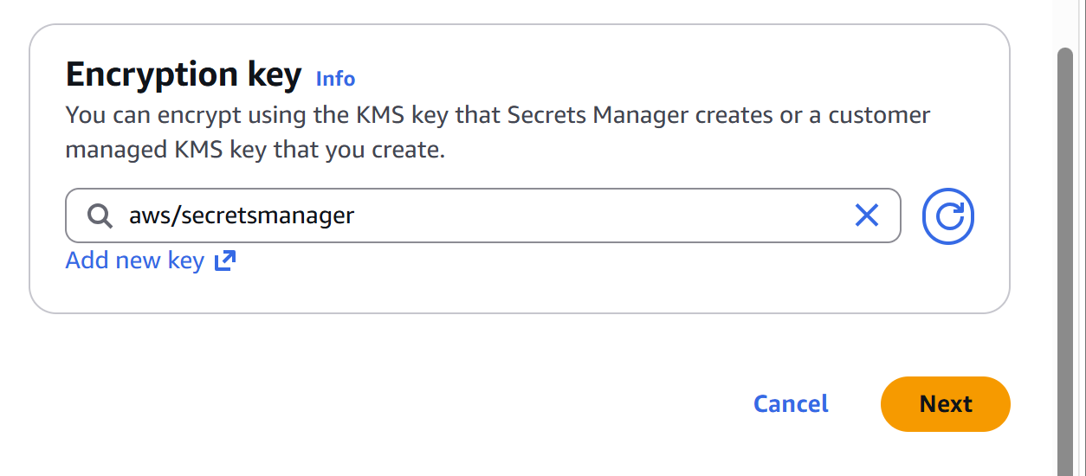
Step 5: Secret Name
Enter
MyDatabaseSecret
Description
Database credentials
Click
Next
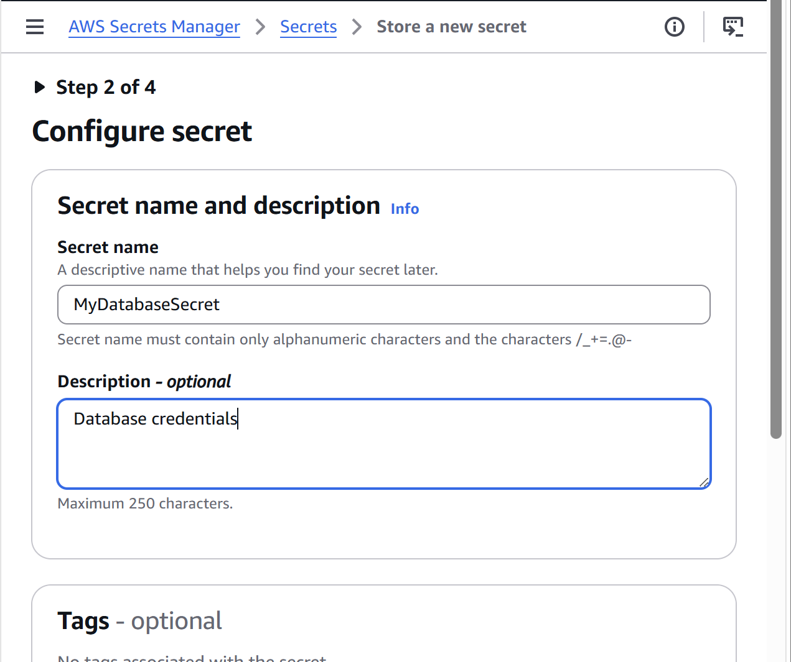
Step 6: Configure Rotation
For beginners
Choose
Disable automatic rotation
(Automatic rotation requires Lambda.)
Click
Next
Step 7: Review
Review all settings.
Click
Store
Step 8: View the Secret
You should now see
MyDatabaseSecret
Click it.
Information displayed:
- Secret name
- ARN
- KMS Key
- Creation date
- Last changed date
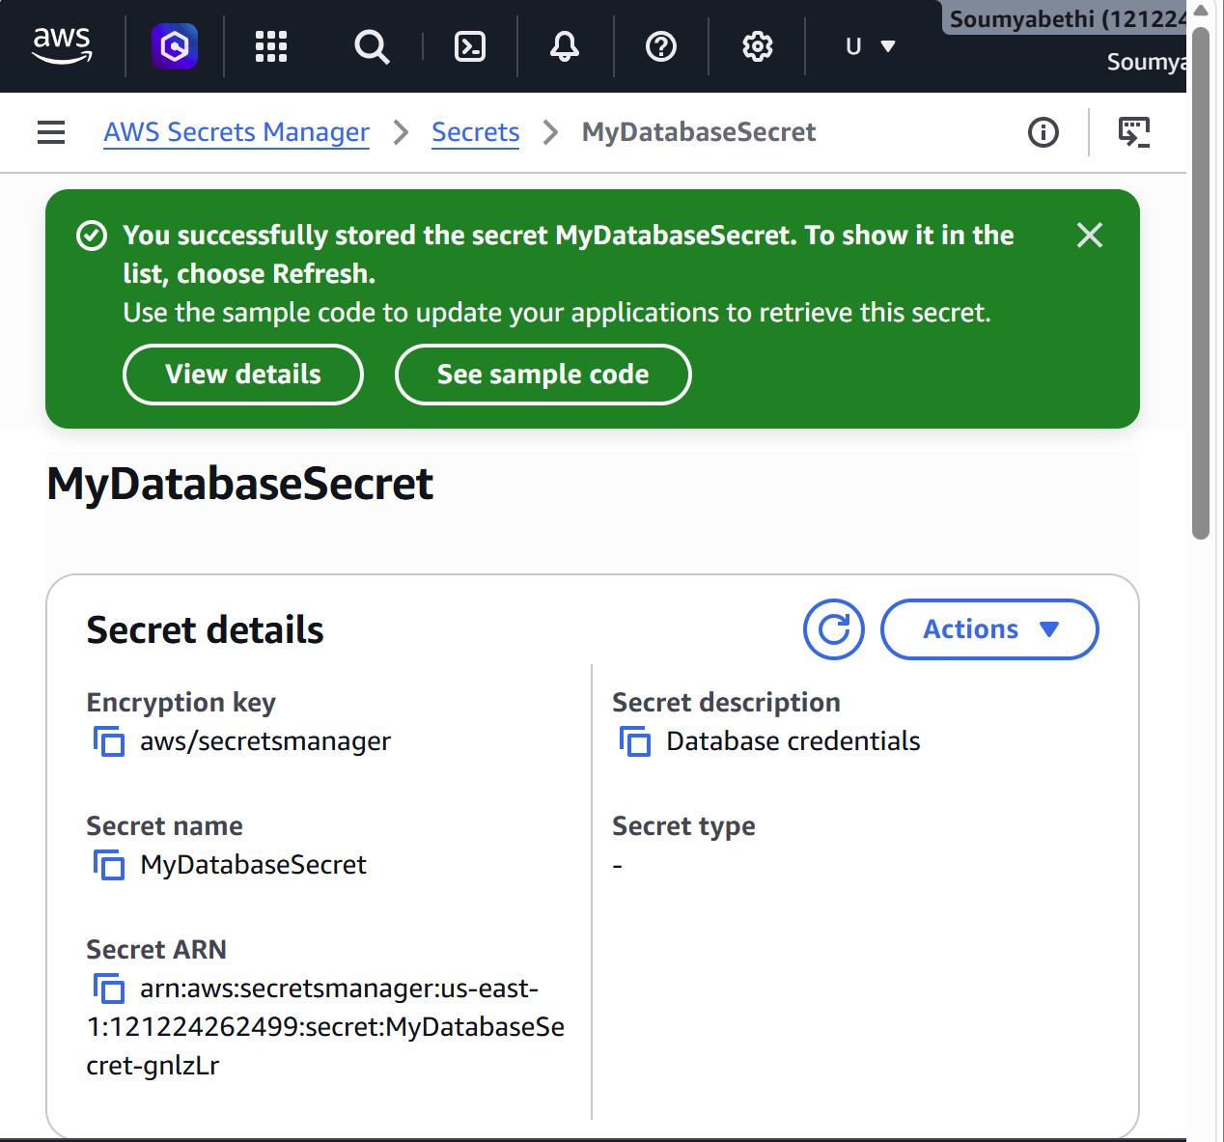
Step 9: Retrieve Secret
Click
Retrieve secret value
Click
Retrieve
Output
{
"username":"admin",
"password":"MyPassword@123"
}
The secret value remains encrypted until you explicitly retrieve it.
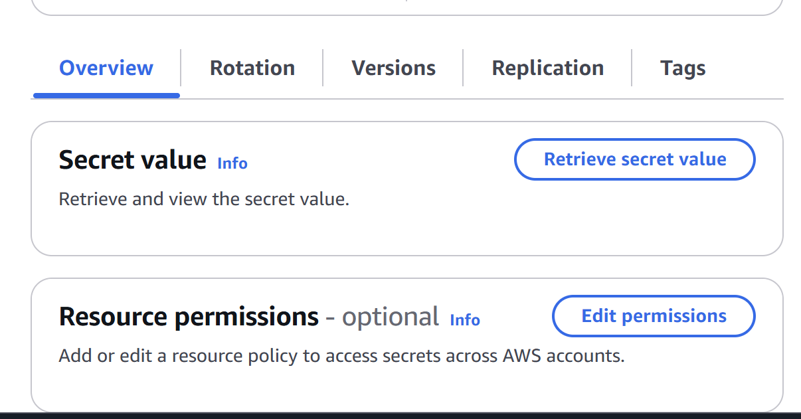
Step 10: Edit Secret
Click
Retrieve secret value
Click
Edit
Change
password
From
MyPassword@123
To
Welcome@123
Click
Save
Now retrieve it again.
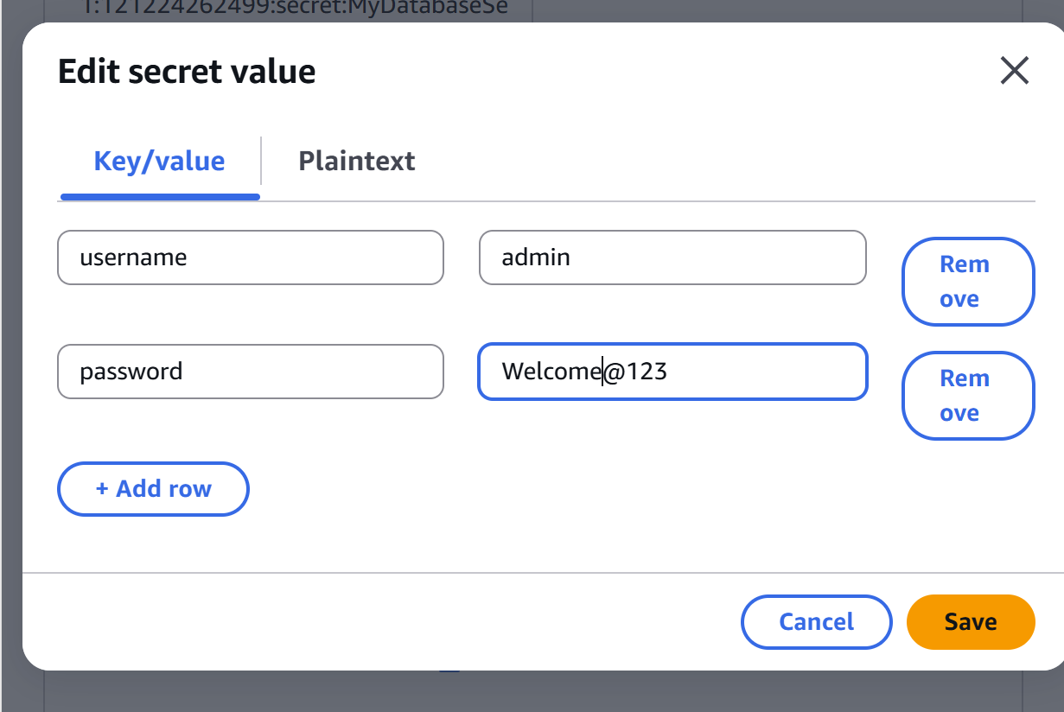
Output
{
"username":"admin",
"password":"Welcome@123"
}
Step 11: View Secret Versions
Open
Versions
You will notice multiple versions, for example:
Version 1
Current

Version 2
Previous
Secrets Manager keeps versions whenever the secret changes.
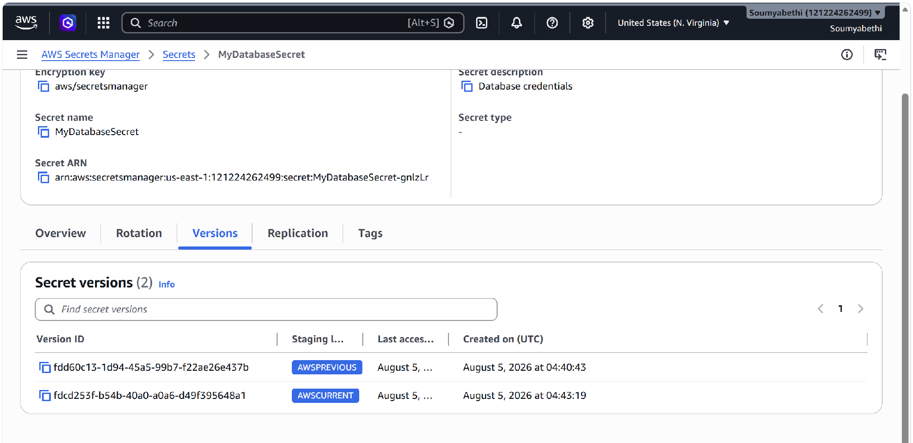

Step 12: Delete Secret
Select
Delete secret
Choose a recovery window (for example, 7 days).
Confirm deletion.
The secret enters a pending deletion state and can be restored during the recovery window.
Step 13: Restore Secret (Optional)
Before the recovery period ends:
Open the deleted secret.
Click
Cancel deletion
The secret becomes active again.

